Assignment 1 :- Create an IAM user with username of your own wish and grant

administrator policy.

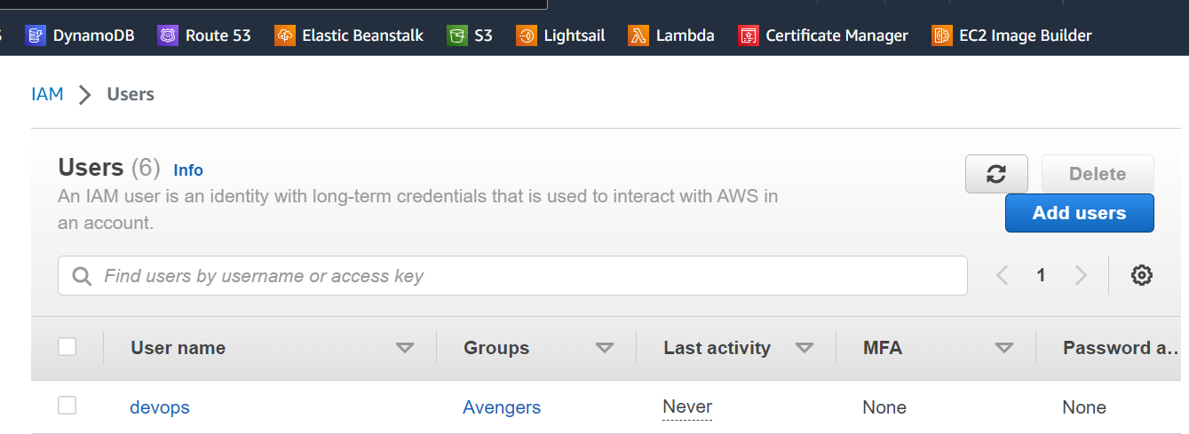

Assignment 2 :- Hello students, in this assignment you need to prepare a

developers team of avengers.

- Create 3 IAM users of avengers and assign them in developer’s groups with

IAM policy.

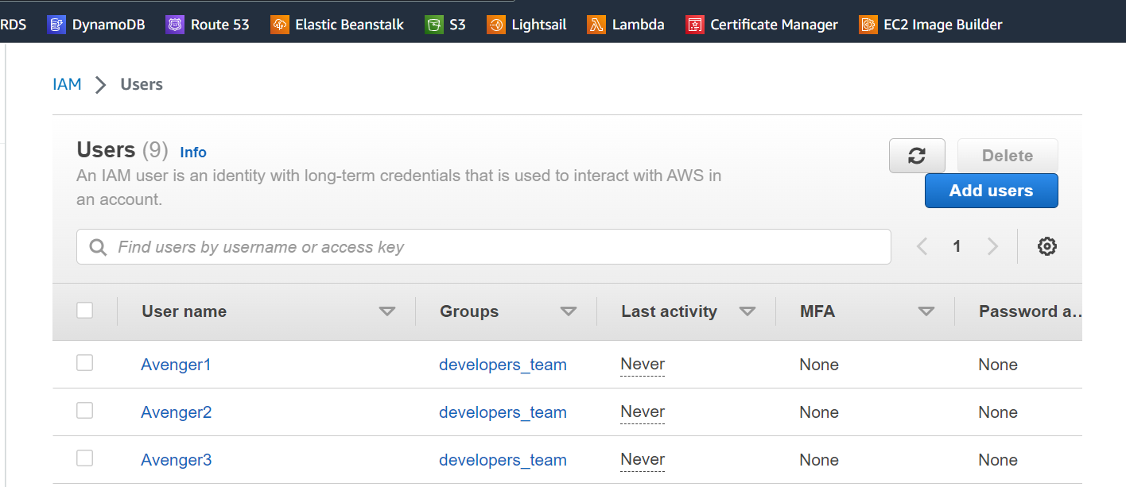

Assignment 3 :- Define a condition in policy for expiration like

"DateGreaterThan": {"aws:CurrentTime":

"2020-04-01T00:00:00Z"},

"DateLessThan": {"aws:CurrentTime":

"2020-06-30T23:59:59Z"}

Define the span of 4 months as per your wish

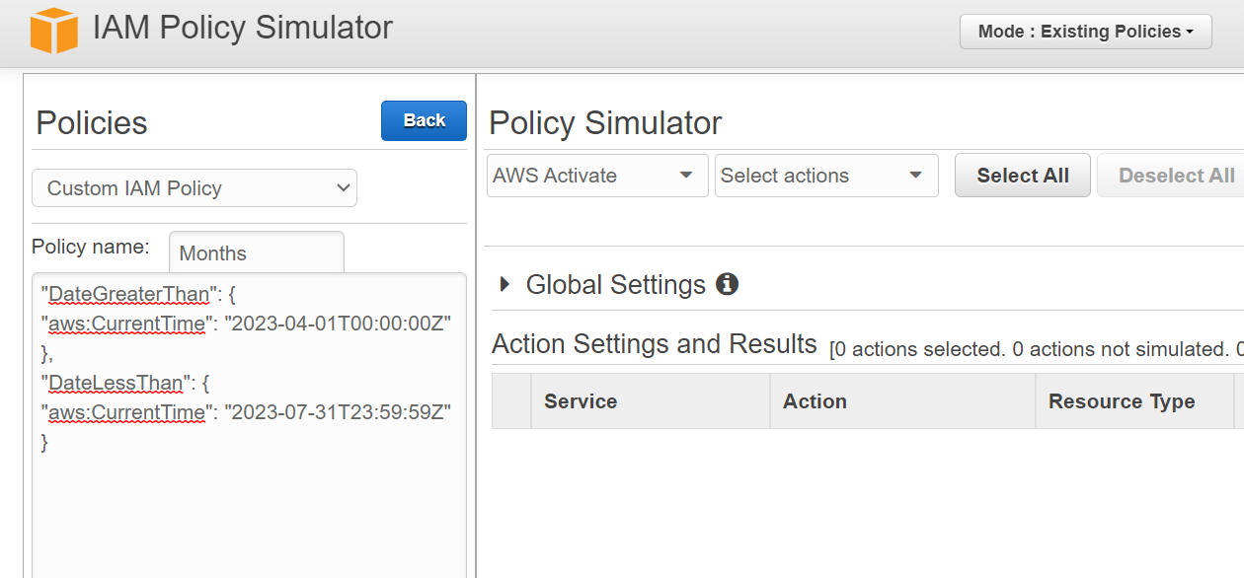

Assignment 4 :- Prepare 15 authentic MCQ questions related to IAM.

Sure, here are 15 multiple-choice questions:

1. What does IAM stand for in AWS?

a) Identity and Access Model b) Internet Access Management c) Identity and Account Management d) Identity and Access Management

1. Which of the following is not a component of IAM?

a) Users b) Groups c) Instances d) Roles

1. What is the primary purpose of IAM roles?

a) Assigning permissions to users b) Managing password policies c) Providing temporary access credentials d) Creating custom policies

1. How does IAM support the principle of least privilege?

a) By granting all permissions by default b) By granting full administrative access to all users c) By allowing users to modify their own permissions d) By granting only the permissions necessary for a user's tasks

1. What is the maximum number of IAM users you can create per AWS account by default?

a) 10 b) 50 c) 100 d) Unlimited

1. Which AWS service allows you to integrate external identity providers with AWS IAM?

a) AWS S3 b) AWS Lambda c) Amazon Cognito d) Amazon RDS

1. Which statement best describes an IAM policy?

a) It defines the maximum number of users in an AWS account. b) It determines the cost of using AWS resources. c) It defines permissions and access to AWS resources. d) It enforces encryption for data at rest.

1. What is the recommended way to grant temporary access to AWS resources to users, applications, or services?

a) Using access keys b) Sharing password information c) Creating IAM roles d) Using root user credentials

1. Which of the following actions can only be performed by the root user in an AWS account?

a) Creating IAM users b) Creating IAM policies c) Creating IAM roles d) Creating IAM groups

1. What is the purpose of an IAM policy simulator?

a) To create new IAM policies b) To audit existing IAM policies c) To test IAM users' authentication d) To monitor network traffic

1. Which type of policy should you attach to an IAM user to grant permissions that allow them to modify their own credentials and password policies?

a) Managed policy b) Inline policy c) AWS Identity policy d) Customer-managed policy

1. How can multi-factor authentication (MFA) enhance the security of an AWS account?

a) It automatically encrypts all data in the account. b) It requires users to have multiple IAM roles. c) It adds an extra layer of verification during sign-in. d) It allows unlimited access to AWS resources.

1. Which AWS service provides a web-based console for users to sign in and access resources?

a) AWS S3 b) AWS EC2 c) AWS IAM d) AWS Management Console

1. What is the purpose of an IAM group?

a) To represent a collection of AWS resources b) To grant permissions to multiple users at once c) To create IAM policies for administrators d) To enforce AWS cost control

1. What happens when an IAM user is added to multiple IAM groups with conflicting permissions?

a) The user's account will be suspended. b) The user will be automatically removed from all groups. c) The user will inherit the permissions from all groups. d) The user will lose access to all AWS resources.

Assignment 5 :- Launch your linux instance in IAM and update your machine.

